Online Club Payment Facility

We have introduced a facility to allow you to pay club expenses securely online with your debit or credit card.
***We would encourage ALL members to avail of this facility***
REGISTERING YOUR EASY PAYMENTS PLUS ACCOUNT
If this is your first time using Easy Payments Plus, please follow the below steps.
- Go to the club’s website and select the Easy Payments Plus button.
- You will automatically be brought to a page which will display all the membership fees. You will see a ‘Log In’ button on the top right of the screen. Press this.
- The first time you use the system you will be asked if you have an Easy Payments Plus account, please select NO and fill in the below fields.

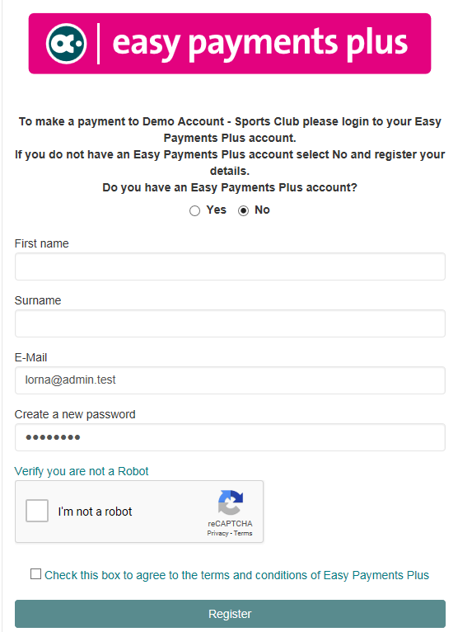

- Please note that when making up a password, it must contain a minimum of 8 characters, at least 1 uppercase letter, 1 lowercase letter, 1 number and 1 special character. Examples of special characters are ?!@
- You will then be brought to the below screen. Please select a type. Please note these are just examples and could vary for your own club.

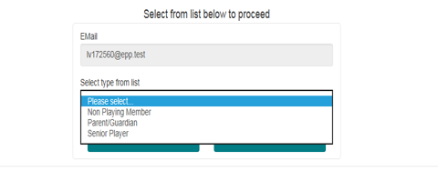

- You will then be asked to fill out registration details for the person who is making the payment to the club. You will then be brought to a screen to add any additional members you wish to register.
- Please ensure to add all members you want to register before proceeding to payment.
If you have an Easy Payments Plus Account already, maybe with a school or another club please follow the below steps to activate your account with the new club.
- You will need to log onto to the club website and click on the Easy Payments Plus button.
- You will automatically be brought to a page which will display all the membership fees. You will see a ‘Log In’ button on the top right of the screen. Press this.
- You will be brought to the Easy Payments Plus login screen, when asked if you have an account already select YES.
- Enter your email address and password that you use to access your other accounts through Easy Payments Plus. You will then be brought to the below screen.
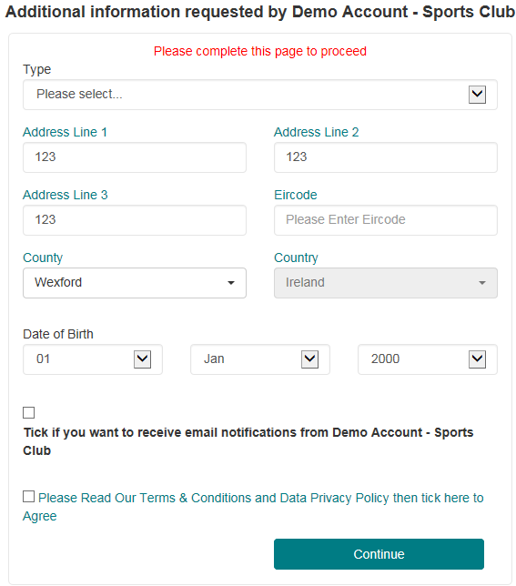o

- Please enter in all details and click continue. You will be brought to a screen and you will be asked to ‘Add New Names’. Please add all additional names you wish to register.
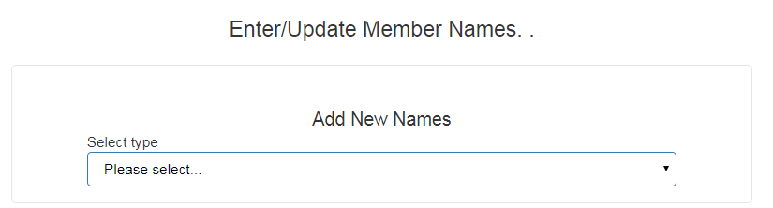

PAYMENT
- Once you have completed the registration process, please follow the instructions on the screen to select the appropriate items(s) to pay and then enter your card details when prompted.
- You will receive a receipt via email for every payment you make.
- From then on you can login to your account at any time and look at payments you have made and any instalments you have setup.
SECURITY
- All payments are processed using SSL (Secure Socket Layer) technology, which ensures the security of the transaction as it is being processed.
- All payments are processed by a PCI (Payment Card Industry) compliant payment processor, which ensures all card holder’s data is managed securely.
- Easy Payments Plus has updated its policies, processes and procedures to ensure that student data is held in a GDPR compliant manner.
If you have any questions, please do not hesitate to contact the club.

